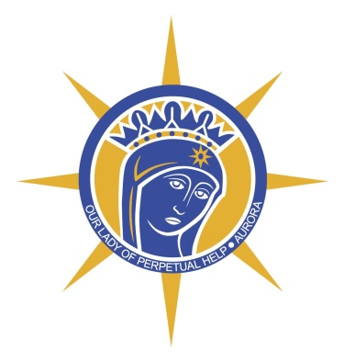**Our Lady of Perpetual Help Parish**

**Faith Formation Program 2019-2020**

**Student & Home Based (Family) Programs**

***Registration Information and Forms***

Thank you for continuing your family’s faith journey with Our Lady. As in the past, we are offering both a student-based program and a home-based program.

Our mission and goal is Gospel oriented: to form disciples as individuals, as families, and as a parish. We will accomplish this by providing a variety of opportunities for both personal and family growth in our Catholic faith and traditions. We want to continue to support your faith journey, enhance your role as the primary catechists of your children, and to be a resource as we all mature in Jesus Christ.

In addition to our **F**aith **F**ormation **P**rograms, we have sacramental preparation programs for those families and children seeking to celebrate First Reconciliation, First Eucharist and Confirmation. For students who attend Catholic School, FFP sacramental registration is required in order to celebrate sacraments.

To reach our Faith Formation Program mission and goals, our program is divided into two cycles, Autumn 2019 and Winter 2020. Please review the enclosed calendar and schedule for the specific times and dates.

***Autumn 2019 Session*: September through December**

**September** is our kick off month. Parents participating in either the student-based or the home-based (family) programs are expected to participate in either the Sunday afternoon or Monday evening session. Each session will feature a different noted speaker. The session will end with an important explanation of our programs and family lesson plans. Student/family books will be distributed. This is a parent only session.

**October and November** are our Family Faith and Fun Nights. Parents **and** students from both programs are expected to attend either the Sunday or Monday option. Come prepared with finished assigned lessons. **December** is our Family Advent Celebration.

***Winter 2020 Session:* Student-based Program**

**Grade K – Grade 5 Sunday Morning 9:15-10:45 am OR**



**Monday Afternoon 3:45-5:15 pm**

**Grades 6, 7, & 8 Sunday Morning 9:15-10:45 am OR**

**Monday Evening 6:30-8:00 pm**

**Transportation**

If your child attends Aurora City Schools, school bus transportation to our program on Monday afternoon is provided (though not required). See the Aurora Schools website for an Alternative Transportation form. For families not in the Aurora City School system, transportation must be provided.

**Assessment Requirements**

All 6th, 7th and 8th Grade students have an end of the year final exam, with the exception of those students that turn in all homework and classroom assessment by the end of the year.

The Diocese of Youngstown requires two years of religious education and faithful attendance in the program before the sacrament of Confirmation can be conferred. **Additional** sessions will be scheduled on Sunday evenings for 8th graders seeking the Sacrament of Confirmation.

**Flexible Program for Middle Schoolers**

Recognizing our busy schedules, conflicts, illness and unforeseen events, we have developed a flexible program for 6th, 7th and 8th students who miss a class session. These students are expected to attend all classes; therefore any missed classes must be made up by attending the other session. Example: student regularly attends FFP on Monday but have a school/family conflict, the student is required to attend the prior Sunday session for that week and turn in home assignments.



***Winter 2020 Session:* Home-Based (Family) Program**

This inter-generational program is designed to assist parents who are sharing their faith with their children in the home context.

In addition to the autumn sessions, families gather in the Parish Hall on the scheduled dates for their afternoon session. Lunch will not be provided this year, families are welcome to bring their own lunch and eat in the Parish Hall after Sunday Mass. Sessions will begin promptly at 12:45.

Home assignments are due at each monthly session. All assignments are due by the end of April to receive religious education credit for the year.

According to diocesan policies, those anticipating First Reconciliation, First Eucharist or Confirmation must faithfully attend all of the home-based sessions **AND** participate fully in the sacramental preparation sessions.

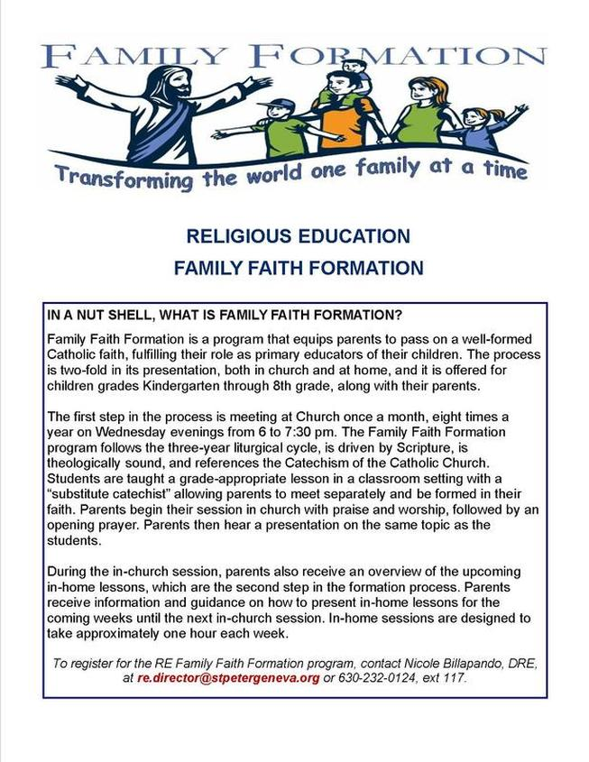

**FEE SCHEDULE** To receive the fee rate below, it is expected that every family contribute at least $12.50 per week by the use of envelopes or Online Giving and all students are expected to use stewardship envelopes found in the Narthex kiosk. **All fees are due at the time of registration.**

**FFP Program Fees**

1st child $75.0 0

2nd child $50.0 0

3rd child $50.00

**Sacramental Fees**

Reconciliation/Eucharist

one fee $75.00

Confirmation $75.00

Cash, check (payable to Our Lady), or online payment is accepted. To use Online Giving, go to [www.olphaurora.org](http://www.olphaurora.org), click tab for “Online Giving” and use either your parish account or “Quick Give.” Select FFP Registration.

Any balance from a previous year **must be paid** before registering for the current year.

*If you are experiencing financial difficulty, please speak with the pastor to make arrangements.*

**RETURN THIS FEE CALCULATION & FEES WITH COMPLETED REGISTRATION DOCUMENTS BY AUGUST 12, 2019**

**FEE CALCULATION**

**Child 1 Name________________________________________**

Grade____________

Circle Day: Sun Mon/aft Mon/pm

FFP Fee $75.00___________

Sacramental Fee $75.00___________

Subtotal **$__________**

**Child 2 Name________________________________________**

Grade____________

Circle Day: Sun Mon/aft Mon/pm

FFP Fee $50.00___________

Sacramental Fee $75.00___________

Subtotal **$__________**

**Child 3 Name________________________________________**

Grade____________

Circle Day: Sun Mon/aft Mon/pm

FFP Fee $50.00___________

Sacramental Fee $75.00___________

Subtotal **$__________**

**Child 4 Name________________________________________**

Grade____________

Circle Day: Sun Mon/aft Mon/pm

FFP Fee $0.00_____________

Sacramental Fee $75.00___________

Subtotal **$__________**

**GRAND TOTAL $___________**

🞐 Cash 🞐Check 🞐Online

**ALL REGISTRATION DOCUMENTS & FEES ARE DUE**

**BY AUGUST 12, 2019**

**CHECK LIST:**

**_____REGISTRATION FORM** (two sided) Please update information as needed.

**_____PHOTO CONSENT / MEDICAL EMERGENCY FORM** (two sided)

_____**BAPTISMAL CERTIFICATE** (if not already on file in the parish office)

_____**FEE CALCULATION** (on the reverse of this page)

_____**FULL PAYMENT**

**OPTIONS:**

**a. Online Payment** (using credit card or bank debit), go to [www.olphaurora.org](http://www.olphaurora.org), click tab “Online Giving” and use either your parish account or “Quick Give.” Select FFP Registration.

**b. Check** payable to **Our Lady**

**c. Cash**

**Drop off completed packet to the Parish Office or Mail:**

**Our Lady of Perpetual Help**

**ATTENTION: Faith Formation Office**

**342 S. Chillicothe Rd. Aurora, OH 44202**

**Please put our student absentee phone number in your cell phone now!**

**330-562-8519 X333**



**Do You Want To Teach?**

**Fees are reduced** for the children of catechist/teachers. Our program is successful because of the commitment of our catechists and volunteers.